Database Project Report
Library Management System

Project - 1
Name: Rojan Chandra Poudel

Contents
1. Executive Summary 1
2. Introduction 1
3. Task 1 - Enhanced Entity-Relationship Diagram (EERD) 2
4. Task 2 - Relational Data Structures and Normalisation 3
Table Name: Users 3
Table Name: Member 3
Table Name: Student 4
Table Name: Staff 4
Table Name: Book 5
Table Name: Author 5
Table Name: Publisher 5
Table Name: Category 5
Table Name: Bookcopy 6
Table Name: Loan 6
Table Name: Reservation 6
Table Name: Fine 7
Table Name: Bookauthor 7
First Normal Form (1NF) 7
Second Normal Form (2NF) 8
Third Normal Form (3NF) 8
Summary of Final Tables 8
5. Task 3 - SQL DDL and DML Scripts 10
6. Task 4 - Sample SQL Queries 28
Query 1: ORDER BY 28
Query 2: LIKE 29
Query 3: Aggregate Function 30
Query 4: Aggregate Function 31
Query 5: JOIN 32
Query 6: UPDATE 33
7. Task 5 - NoSQL Queries (MongoDB) 34
8. Task 6 - Concurrency Control and Transaction Processing 38
9. Conclusion 39
10. References 39
11. Appendices 40
Appendix A - EERD 40
Appendix B - SQL Server Database Implementation 40

Figure 1 : EERD 3
Figure 2 : ALL in One 9
Figure 3 : Database created 10
Figure 4 : Creating table script 16
Figure 5 : SQL Server INSERT script 22
Figure 6 : Select from member 22
Figure 7 : Select from student 23
Figure 8 : Select from staff 23
Figure 9 : Select from book 24
Figure 10 : Select from Author 24
Figure 11 : Select from publisher 25
Figure 12 : Select from Category 25
Figure 13 : Select from Bookcopy 26
Figure 14 : Select from Loan 26
Figure 15 : Select from reservation 27
Figure 16 : Select from Fine 27
Figure 17 : Select from Bookauthor 28
Figure 18 : ORDER BY Query 29
Figure 19 : Like QUERY 30
Figure 20 : Aggregate Function 30
Figure 21 : Between Query 31
Figure 22 : JOIN Query 33
Figure 23 : UPDATE Query 34
Figure 24 : Select query to check updated value 34
Figure 25 : Creating MongoDB Database and Collection 35
Figure 26 : Inserting Documents 36
Figure 27 : Displaying All Documents 37
Figure 28 : Filtering Documents 37
Figure 29 : Comparison Query 38

1. Executive Summary
The objective of the proposed database system is to create a Library Management Database which will be able to manage library members, books, authors, publishers, categories, physical copies, loans, reservations and fines in an efficient manner. In addition to this, it is essential that the database must provide an organized and efficient means of storage and management of library information. The project begins with an Enhanced Entity-Relationship diagram that shows various entities along with their attributes, relationships, keys, and cardinality and participation constraints. An associative entity is used to solve many-to-many relationship that exists between the entities books and authors. Moreover, member entity has been further specialized into two entities namely Student and Staff. The conceptual model has been converted into relations and normalized. The database has been implemented using Microsoft SQL Server. It includes primary and foreign keys, constraints as well as some sample records. SQL queries have been prepared in order to show data extraction and manipulation through various operations like filtering, sorting, aggregating, joining and updating.
Further, a MongoDB database has also been prepared to show how the same data can be stored and managed in a NoSQL database and how documents can be created and retrieved from the database. Transaction processing, concurrency control, access control, backup and recovery as well as other database functions have been discussed with respect to this report in order to ensure data integrity, security and efficiency. Thus, the proposed library management database will be able to serve as a basis for managing library information.

2. Introduction
Library management system represents an important database application which helps libraries manage and regulate information on books, members, authors, publishers, borrowing transactions, reservation, and fines. Manual management of the above mentioned information can cause data duplication, hindrances in accessing the information and inconsistencies in library records. A well designed database system can help avoid such problems through providing a good framework for storing and updating information.
In this project, emphasis will be placed on designing and development of Library Management Database System which will assist in carrying out the main activities of the library. The intended database will manage information on library members, books, authors, publishers, categories, book copies, loaning transactions, reservation, and fines. The database will keep the relationships between the entities in mind and will provide data integrity and minimize unnecessary data redundancy. Database design techniques will be used in this project through EERD, relational data structures, and normalization. Physical database will be designed with Microsoft SQL Server including necessary primary keys, foreign keys and integrity constraints. SQL commands will be used for retrieval and manipulation of data while MongoDB will be used for demonstration of NoSQL databases.
Transaction management, concurrency management, access control, backup and recovery, security, and efficiency will be considered in this project in order to build a reliable database system. This project will demonstrate the application of the theoretical knowledge of database systems in a library management scenario.

3. Task 1 - Enhanced Entity-Relationship Diagram (EERD)
Enhanced Entity Relationship Diagram (EERD) outlines the conceptual framework of the Library Management Database System. The EERD identifies the major entities involved in the activities of the library, their properties, and the relationships that exist among entities. Also, the EERD describes the cardinality and participation constraints that illustrate how the entities relate to one another.
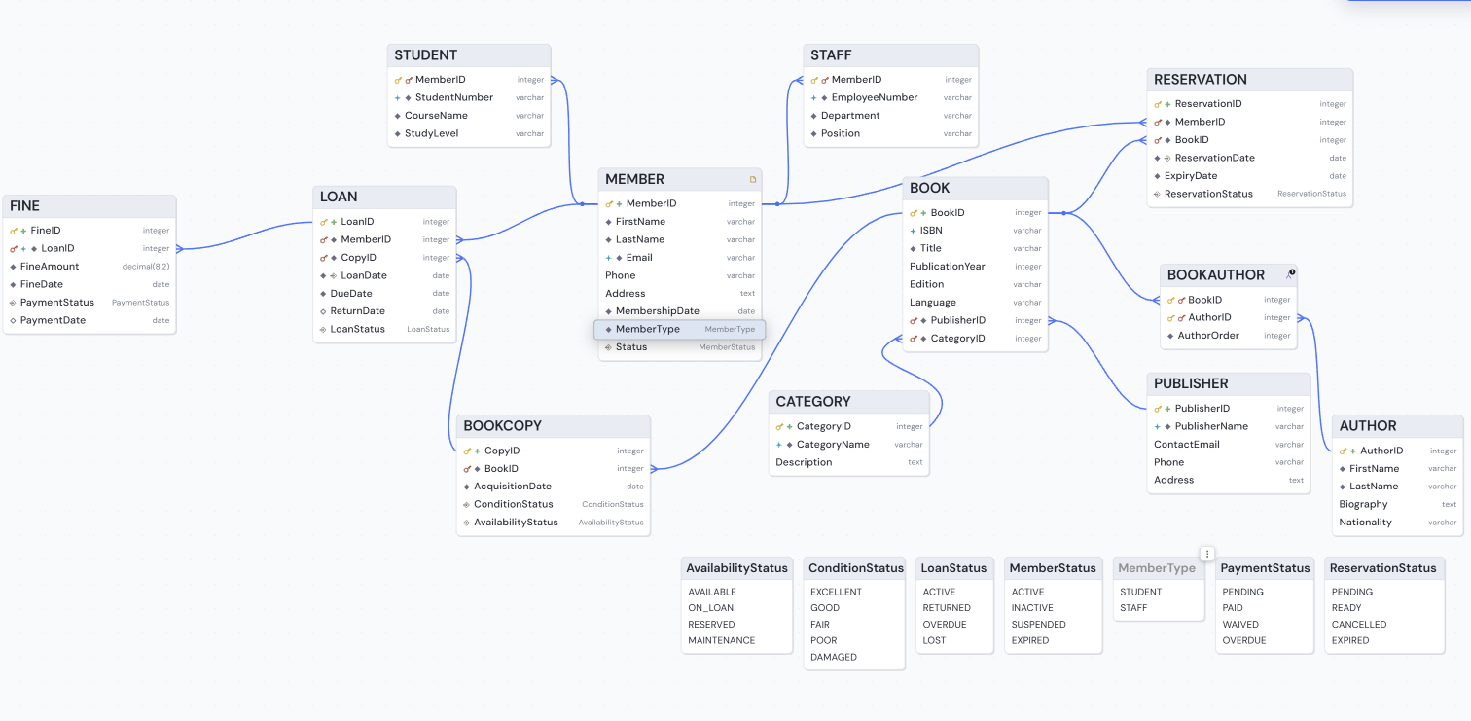
Figure 1 : EERD

4. Task 2 - Relational Data Structures and Normalisation
From the library management system Enhanced Entity Relationship Diagram (EERD), the conceptual entities are converted into relational tables. Each entity as a table, attributes as columns, and relationships with primary keys (PK) and foreign keys (FK) have been implemented. We used specialisation and generalisation to represent various user roles effectively and to eliminate repetition in the data.

Table Name: Users
Attribute | Description
User ID (PK) | Unique identifier for system users
Username | Login username
Password | Encrypted user password
Role | User role (Member, Admin, Staff)

Table Name: Member
Attribute | Description
Member ID (PK) | Unique member identifier assigned to library members.
FirstName | Member first name
LastName | Member last name
Email | Member email address
Phone | Member Contact phone number
Address | Residential address
MembershipDate | Date when the member registered in library
MemberType | Type of member
Status | Current membership status(Active/Inactive)

Table Name: Student
Attribute | Description
MemberID (PK,FK) | Identifies the student and also link student to the MEMBER relation.
StudentNumber | Unique Identification number assigned.
CourseName | Name of the Course being studied.
StudyLevel | Current academic level

Table Name: Staff
Attribute | Description
MemberID (PK/FK) | Identifies the stuff and also link staff to the MEMBER relation.
EmployeeNumber | Unique identification number assigned.
Department | Department in which the staff member works
Position | Role of the staff member

Table Name: Book
Attribute | Description
Book ID (PK) | Unique identifier assigned to each book
ISBN | International Standard Book Number used to identify the book.
Title | Title of the book
Publication Year | Year of publication
Edition | Edition of the book.
Language | Language in which the book is published
Publisher ID (FK) | References Publisher (Publisher ID)
Category ID (FK) | References Category (Category ID)

Table Name: Author
Attribute | Description
AuthorID (PK) | Unique author identifier
FirstName | Author first name
LastName | Author last name
Biography | Brief biographical information
Nationality | Author nationality

Table Name: Publisher
Attribute | Description
PublisherID (PK) | Unique publisher identifier
Name | Publisher name
Address | Publisher address
Phone | Contact number

Table Name: Category
Attribute | Description
CategoryID (PK) | Unique category identifier
CategoryName | Category name (e.g. Fiction, Science,…)
Description | Description of the book contains.

Table Name: Bookcopy
Attribute | Description
CopyID (PK) | Unique identifier for each physical copy of the book.
BookID (FK) | Identifies the book to which the orginal physical copy belongs
AcquisitionDate | Date when the physical copy was acquired
ConditionStatus | Current condition of copied book
AvailabilityStatus | Current availability of the physical copy(available/on loan)

Table Name: Loan
Attribute | Description
Loan ID (PK) | Unique loan identifier
Member ID (FK) | References Member (Member ID)
CopyID (FK) | Identifies the physical book copy
Loan Date | Date of issue
Due Date | Due return date
Return Date | Actual return date
LoanStatus | Status of loan currently(active, returned, overdue, or lost)

Table Name: Reservation
Attribute | Description
ReservationID (PK) | Unique reservation identifier
MemberID (FK) | Identifies Member who made the reservation
BookID (FK) | References Book (Book ID)
ReservationDate | Date of reservation
ExpiryDate | Reservation expiry date
ResevationStatus | Current status of the reservation

Table Name: Fine
Attribute | Description
FineID (PK) | Unique fine identifier
LoanID (FK) | Identifies the loan associated with the fine
FineAmount | Amount charged
FineDate | Fine issued date
PaymentStatus | Current Payment Status of the fine
PaymentDate | Fine paid date

Table Name: Bookauthor
Attribute | Description
BookID(PK,FK) | Identifies book and references BOOK
AuthorID(PK,FK) | Identifies author and references AUTHOR
Description | Description of the book contains.

First Normal Form (1NF)
The requirement of the First Normal Form (1NF) is that each attribute should have atomic value. Repeating groups and multivalued attributes should not be there in any attribute of 1NF. In Library Management system, multiple authors, copies, loans and reservations are not stored in one single field because these are kept in relevant relations. Relation "BOOKAUTHOR" takes care of many-to-many relationship between BOOKS and AUTHORS through composite key. This is how all the relations meet the requirements of First Normal Form (1NF).

Second Normal Form (2NF)
The Second Normal Form (2NF) implies that for a relation to satisfy 2NF, the relation should first satisfy the First Normal Form (1NF) condition and all non-prime attributes should be fully functionally dependent on the whole of the primary key and not some part of it. For instance, most relations in the Library Management System have a one-attribute primary key, thus there are no partial dependencies. However, in the BOOKAUTHOR relation, the primary key is a composite one (BookID, AuthorID) and the attribute AuthorOrder depends on both.

Third Normal Form (3NF)
The Third Normal Form (3NF) demands that a relation must be in 2NF and must not have any transitive dependency. In the 3NF, non-key attributes should depend only on the primary key and not on other non-key attributes. In Library Management System, the information regarding publishers and categories are stored in two separate relations named PUBLISHER and CATEGORY respectively, rather than duplicating this information in BOOK relation. For example, PublisherName will depend on PublisherID, but PublisherID will be dependent on BOOK. Likewise, CategoryName will depend on CategoryID. By storing information in this way, we avoid any extra dependency and data redundancy. The left out relations have attributes that directly depend on primary keys. Hence there will be no transitive dependency in the proposed database design, which fulfills the requirement of 3NF.

Summary of Final Tables
Relation | Primary Key | Normal Form | Justification
MEMBER | MemberID | 3NF | Attributes depend on MemberID
STUDENT | MemberID | 3NF | Attributes depend on MemberID
STAFF | MemberID | 3NF | Attributes depend on MemberID
BOOK | BookID | 3NF | Publisher and category details are separated
AUTHOR | AuthorID | 3NF | Attributes depend on AuthorID
PUBLISHER | PublisherID | 3NF | Attributes depend on PublisherID
CATEGORY | CategoryID | 3NF | Attributes depend on CategoryID
BOOKCOPY | CopyID | 3NF | Attributes depend on CopyID
LOAN | LoanID | 3NF | All attributes depend on LoanID
RESERVATION | ReservationID | 3NF | Attributes depend on ReservationID
FINE | FineID | 3NF | Attributes depend on FineID
BOOKAUTHOR | BookID + AuthorID | 3NF | AuthorOrder depends on the complete composite key

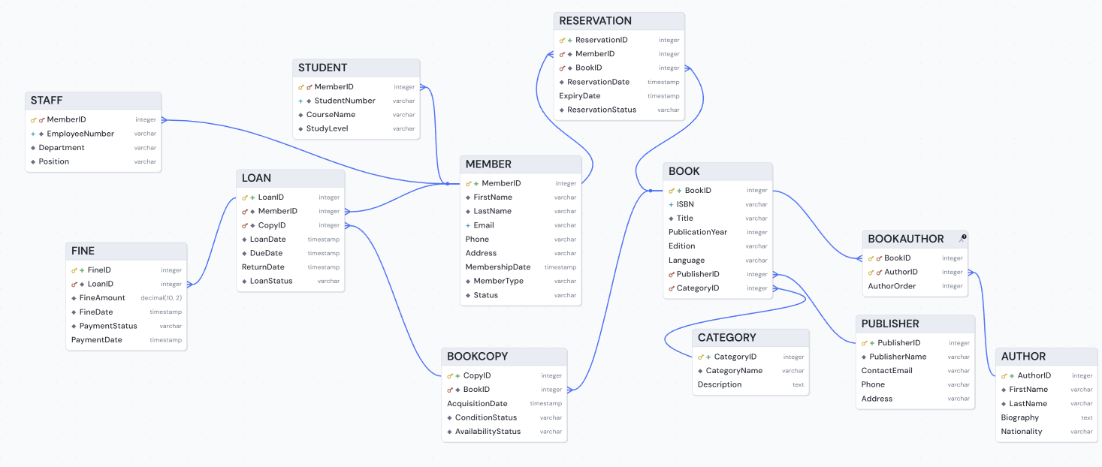
Figure 2 : ALL in One

5. Task 3 - SQL DDL and DML Scripts
Step 1: Create Database

CREATE DATABASE LibraryManagementDB;
GO

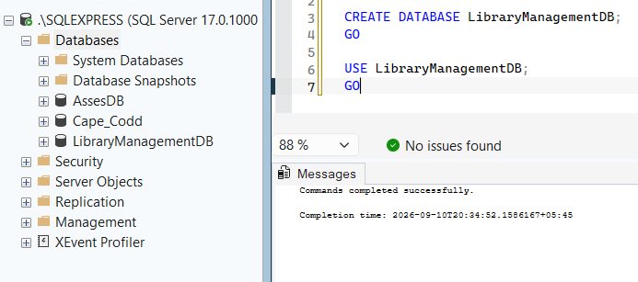
Figure 3 : Database created
USE LibraryManagementDB;
GO

Step 2: Create Tables
CREATE TABLE MEMBER (
MemberID INT PRIMARY KEY,
FirstName VARCHAR(50) NOT NULL,
LastName VARCHAR(50) NOT NULL,
Email VARCHAR(100) NOT NULL UNIQUE,
Phone VARCHAR(20),
Address VARCHAR(150),
MembershipDate DATE NOT NULL,
MemberType VARCHAR(20) NOT NULL,
Status VARCHAR(20) NOT NULL
);
GO

CREATE TABLE STUDENT (
MemberID INT PRIMARY KEY,
StudentNumber VARCHAR(30) NOT NULL UNIQUE,
CourseName VARCHAR(100) NOT NULL,
StudyLevel VARCHAR(30) NOT NULL,
CONSTRAINT FK_STUDENT_MEMBER
FOREIGN KEY (MemberID) REFERENCES MEMBER(MemberID)
);
GO

CREATE TABLE STAFF (
MemberID INT PRIMARY KEY,
EmployeeNumber VARCHAR(30) NOT NULL UNIQUE,
Department VARCHAR(100) NOT NULL,
Position VARCHAR(50) NOT NULL,
CONSTRAINT FK_STAFF_MEMBER
FOREIGN KEY (MemberID) REFERENCES MEMBER(MemberID)
);
GO

CREATE TABLE PUBLISHER (
PublisherID INT PRIMARY KEY,
PublisherName VARCHAR(100) NOT NULL,
ContactEmail VARCHAR(100),
Phone VARCHAR(20),
Address VARCHAR(150)
);
GO

CREATE TABLE CATEGORY (
CategoryID INT PRIMARY KEY,
CategoryName VARCHAR(50) NOT NULL UNIQUE,
Description VARCHAR(200)
);
GO

CREATE TABLE AUTHOR (
AuthorID INT PRIMARY KEY,
FirstName VARCHAR(50) NOT NULL,
LastName VARCHAR(50) NOT NULL,
Biography VARCHAR(500),
Nationality VARCHAR(50)
);
GO

CREATE TABLE BOOK (
BookID INT PRIMARY KEY,
ISBN VARCHAR(20) NOT NULL UNIQUE,
Title VARCHAR(150) NOT NULL,
PublicationYear INT,
Edition VARCHAR(30),
Language VARCHAR(30),
PublisherID INT NOT NULL,
CategoryID INT NOT NULL,

CONSTRAINT FK_BOOK_PUBLISHER
FOREIGN KEY (PublisherID)
REFERENCES PUBLISHER(PublisherID),

CONSTRAINT FK_BOOK_CATEGORY
FOREIGN KEY (CategoryID)
REFERENCES CATEGORY(CategoryID)
);
GO

CREATE TABLE BOOKCOPY (
CopyID INT PRIMARY KEY,
BookID INT NOT NULL,
AcquisitionDate DATE NOT NULL,
ConditionStatus VARCHAR(30) NOT NULL,
AvailabilityStatus VARCHAR(30) NOT NULL,

CONSTRAINT FK_BOOKCOPY_BOOK
FOREIGN KEY (BookID)
REFERENCES BOOK(BookID)
);
GO

CREATE TABLE LOAN (
LoanID INT PRIMARY KEY,
MemberID INT NOT NULL,
CopyID INT NOT NULL,
LoanDate DATE NOT NULL,
DueDate DATE NOT NULL,
ReturnDate DATE NULL,
LoanStatus VARCHAR(30) NOT NULL,

CONSTRAINT FK_LOAN_MEMBER
FOREIGN KEY (MemberID)
REFERENCES MEMBER(MemberID),

CONSTRAINT FK_LOAN_COPY
FOREIGN KEY (CopyID)
REFERENCES BOOKCOPY(CopyID)
);
GO

CREATE TABLE RESERVATION (
ReservationID INT PRIMARY KEY,
MemberID INT NOT NULL,
BookID INT NOT NULL,
ReservationDate DATE NOT NULL,
ExpiryDate DATE,
ReservationStatus VARCHAR(30) NOT NULL,

CONSTRAINT FK_RESERVATION_MEMBER
FOREIGN KEY (MemberID)
REFERENCES MEMBER(MemberID),

CONSTRAINT FK_RESERVATION_BOOK
FOREIGN KEY (BookID)
REFERENCES BOOK(BookID)
);
GO

CREATE TABLE FINE (
FineID INT PRIMARY KEY,
LoanID INT NOT NULL UNIQUE,
FineAmount DECIMAL(10,2) NOT NULL,
FineDate DATE NOT NULL,
PaymentStatus VARCHAR(30) NOT NULL,
PaymentDate DATE NULL,

CONSTRAINT FK_FINE_LOAN
FOREIGN KEY (LoanID)
REFERENCES LOAN(LoanID)
);
GO

CREATE TABLE BOOKAUTHOR (
BookID INT NOT NULL,
AuthorID INT NOT NULL,
AuthorOrder INT NOT NULL,

CONSTRAINT PK_BOOKAUTHOR
PRIMARY KEY (BookID, AuthorID),

CONSTRAINT FK_BOOKAUTHOR_BOOK
FOREIGN KEY (BookID)
REFERENCES BOOK(BookID),

CONSTRAINT FK_BOOKAUTHOR_AUTHOR
FOREIGN KEY (AuthorID)
REFERENCES AUTHOR(AuthorID)
);
GO

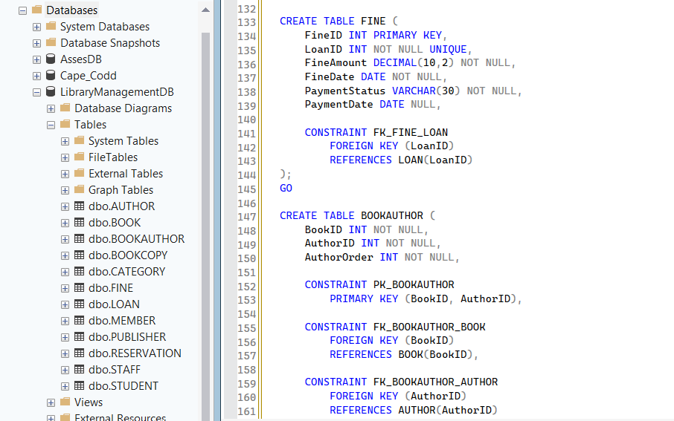
Figure 4 : Creating table script
Step 3: Insert Data
INSERT INTO PUBLISHER
(PublisherID, PublisherName, ContactEmail, Phone, Address)
VALUES
(1, 'Pearson Education', 'contact@pearson.com', '0114567890', 'London, UK'),
(2, 'Oxford University Press', 'info@oup.com', '0186545678', 'Oxford, UK'),
(3, 'McGraw Hill', 'support@mcgrawhill.com', '0215556789', 'New York, USA'),
(4, 'Cambridge University Press', 'info@cambridge.org', '0122334567', 'Cambridge, UK'),
(5, 'Wiley Publishing', 'contact@wiley.com', '0191234567', 'New Jersey, USA');
GO

INSERT INTO CATEGORY
(CategoryID, CategoryName, Description)
VALUES
(1, 'Computer Science', 'Books related to computing and information technology'),
(2, 'Database Systems', 'Books about database design and management'),
(3, 'Business', 'Books related to business and management'),
(4, 'Programming', 'Books covering programming languages and software development'),
(5, 'Networking', 'Books related to computer networks and communication');
GO

INSERT INTO AUTHOR
(AuthorID, FirstName, LastName, Biography, Nationality)
VALUES
(1, 'Thomas', 'Connolly', 'Author and researcher specialising in database systems.', 'British'),
(2, 'Ramez', 'Elmasri', 'Computer scientist and author of database textbooks.', 'American'),
(3, 'Abraham', 'Silberschatz', 'Professor and author in computer science and database systems.', 'American'),
(4, 'Andrew', 'Tanenbaum', 'Computer scientist known for books on operating systems and networking.', 'American'),
(5, 'Robert', 'Martin', 'Software engineer and author specialising in software development.', 'American');
GO

INSERT INTO MEMBER
(MemberID, FirstName, LastName, Email, Phone, Address,
MembershipDate, MemberType, Status)
VALUES
(1, 'Md Golum', 'Sadid', 'md.sadid@gmail.com', '9800000001',
'Sydney, Australia', '2026-01-10', 'Student', 'Active'),

(2, 'Denish Jung', 'Bogati', 'denish.bogati@gmail.com', '9800000002',
'Melbourne, Australia', '2026-01-12', 'Student', 'Active'),

(3, 'Felix Kipkurui', 'Kigen', 'felix.kigen@gmail.com', '9800000003',
'Brisbane, Australia', '2026-01-15', 'Student', 'Active'),

(4, 'Mollick Ifaj', 'Sajid', 'mollick.sajid@gmail.com', '9800000004',
'Perth, Australia', '2026-01-18', 'Student', 'Active'),

(5, 'Aarav', 'Sharma', 'aarav.sharma@gmail.com', '9800000005',
'Adelaide, Australia', '2026-01-20', 'Staff', 'Active'),

(6, 'Emily', 'Wilson', 'emily.wilson@gmail.com', '9800000006',
'Melbourne, Australia', '2026-01-22', 'Staff', 'Active');

(7, 'James', 'Anderson', 'james.anderson@gmail.com', '9800000007',
'Sydney, Australia', '2026-01-25', 'Staff', 'Active'),

(8, 'Sophia', 'Taylor', 'sophia.taylor@gmail.com', '9800000008',
'Brisbane, Australia', '2026-01-27', 'Staff', 'Active'),

(9, 'Daniel', 'Thomas', 'daniel.thomas@gmail.com', '9800000009',
'Perth, Australia', '2026-02-01', 'Staff', 'Active'),

(10, 'Olivia', 'Martin', 'olivia.martin@gmail.com', '9800000010',
'Adelaide, Australia', '2026-02-03', 'Staff', 'Active');

GO

INSERT INTO STUDENT
(MemberID, StudentNumber, CourseName, StudyLevel)
VALUES
(1, '20034792', 'Bachelor of Information Technology', 'Undergraduate'),
(2, '20030161', 'Bachelor of Information Technology', 'Undergraduate'),
(3, '20030046', 'Bachelor of Computer Science', 'Undergraduate'),
(4, '20034382', 'Bachelor of Information Technology', 'Undergraduate'),
(6, '20035001', 'Master of Information Technology', 'Postgraduate');
GO

INSERT INTO STAFF
(MemberID, EmployeeNumber, Department, Position)
VALUES
(5, 'EMP001', 'Library Services', 'Librarian'),
(7, 'EMP002', 'Information Technology', 'IT Officer'),
(8, 'EMP003', 'Library Services', 'Assistant Librarian'),
(9, 'EMP004', 'Administration', 'Administrator'),
(10, 'EMP005', 'Library Services', 'Senior Librarian');
GO

INSERT INTO BOOK
(BookID, ISBN, Title, PublicationYear, Edition, Language,
PublisherID, CategoryID)
VALUES
(1, '9780133970777', 'Database Systems', 2019, '7th', 'English', 1, 2),
(2, '9780073523323', 'Fundamentals of Database Systems', 2020, '7th', 'English', 3, 2),
(3, '9781260084504', 'Operating System Concepts', 2018, '10th', 'English', 3, 1),
(4, '9780133594140', 'Computer Networks', 2021, '6th', 'English', 1, 5),
(5, '9780132350884', 'Clean Code', 2008, '1st', 'English', 1, 4);
GO

INSERT INTO BOOKCOPY
(CopyID, BookID, AcquisitionDate, ConditionStatus, AvailabilityStatus)
VALUES
(1, 1, '2026-01-05', 'Good', 'Available'),
(2, 1, '2026-01-05', 'Excellent', 'Borrowed'),
(3, 2, '2026-01-08', 'Good', 'Available'),
(4, 2, '2026-01-08', 'Good', 'Borrowed'),
(5, 3, '2026-01-10', 'Excellent', 'Available'),
(6, 3, '2026-01-10', 'Good', 'Available'),
(7, 4, '2026-01-12', 'Good', 'Borrowed'),
(8, 4, '2026-01-12', 'Excellent', 'Available'),
(9, 5, '2026-01-15', 'Good', 'Available'),
(10, 5, '2026-01-15', 'Excellent', 'Borrowed');
GO

INSERT INTO LOAN
(LoanID, MemberID, CopyID, LoanDate, DueDate, ReturnDate, LoanStatus)
VALUES
(1, 1, 2, '2026-08-01', '2026-08-15', NULL, 'Borrowed'),
(2, 2, 4, '2026-08-03', '2026-08-17', '2026-08-15', 'Returned'),
(3, 3, 7, '2026-08-05', '2026-08-19', NULL, 'Borrowed'),
(4, 4, 10, '2026-08-07', '2026-08-21', '2026-08-20', 'Returned'),
(5, 5, 1, '2026-08-10', '2026-08-24', NULL, 'Borrowed');
GO

INSERT INTO RESERVATION
(ReservationID, MemberID, BookID, ReservationDate, ExpiryDate, ReservationStatus)
VALUES
(1, 1, 3, '2026-08-02', '2026-08-16', 'Active'),
(2, 2, 1, '2026-08-04', '2026-08-18', 'Completed'),
(3, 3, 5, '2026-08-06', '2026-08-20', 'Active'),
(4, 4, 2, '2026-08-08', '2026-08-22', 'Cancelled'),
(5, 5, 4, '2026-08-10', '2026-08-24', 'Active');
GO

INSERT INTO FINE
(FineID, LoanID, FineAmount, FineDate, PaymentStatus, PaymentDate)
VALUES
(1, 2, 5.00, '2026-08-16', 'Paid', '2026-08-17'),
(2, 4, 2.50, '2026-08-21', 'Paid', '2026-08-22'),
(3, 1, 10.00, '2026-08-20', 'Unpaid', NULL),
(4, 3, 7.50, '2026-08-25', 'Unpaid', NULL),
(5, 5, 12.00, '2026-08-28', 'Paid', '2026-08-29');
GO

INSERT INTO BOOKAUTHOR
(BookID, AuthorID, AuthorOrder)
VALUES
(1, 1, 1),
(1, 2, 2),
(2, 2, 1),
(3, 3, 1),
(4, 4, 1),
(5, 5, 1);
GO

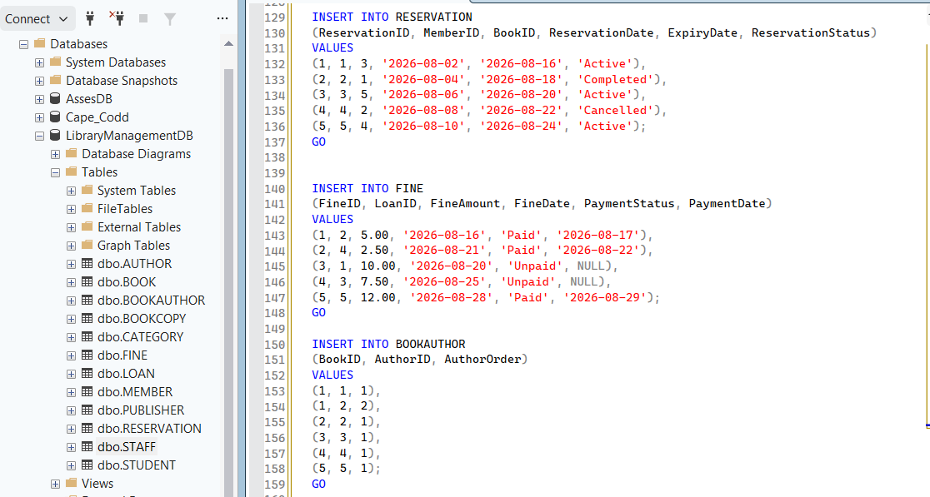
Figure 5 : SQL Server INSERT script

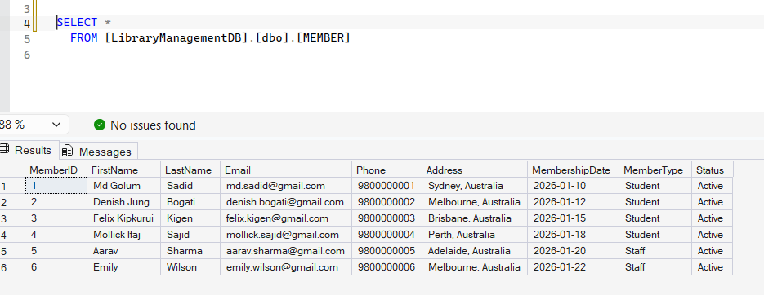
Figure 6 : Select from member

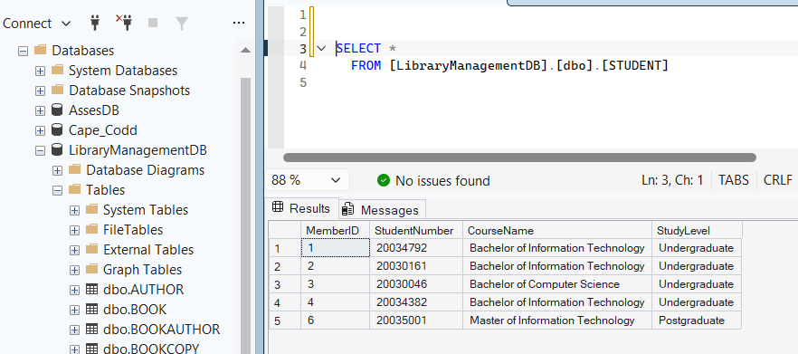
Figure 7 : Select from student

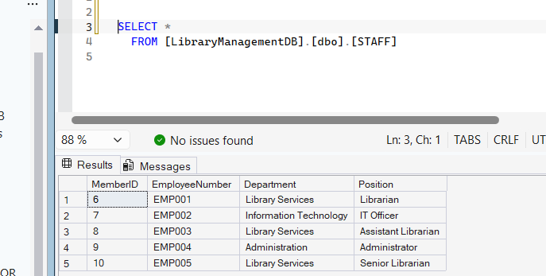
Figure 8 : Select from staff

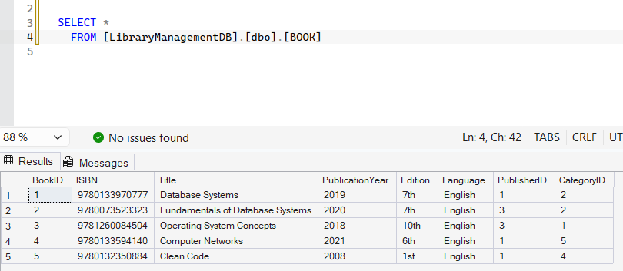
Figure 9 : Select from book

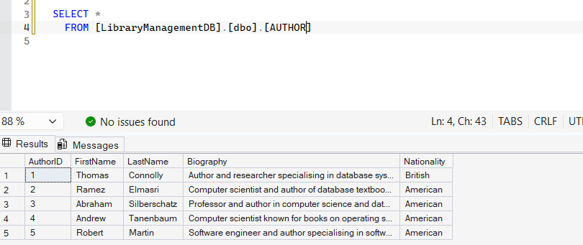
Figure 10 : Select from Author
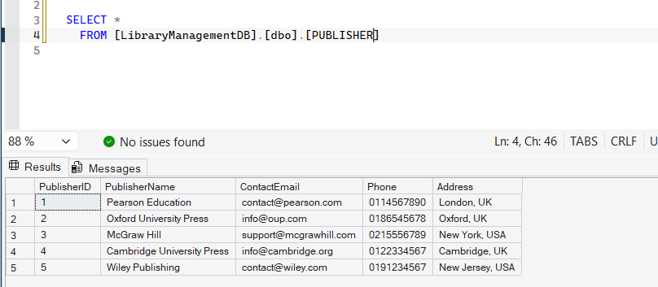
Figure 11 : Select from publisher
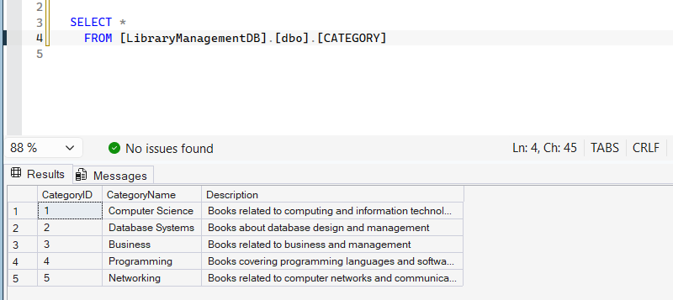
Figure 12 : Select from Category

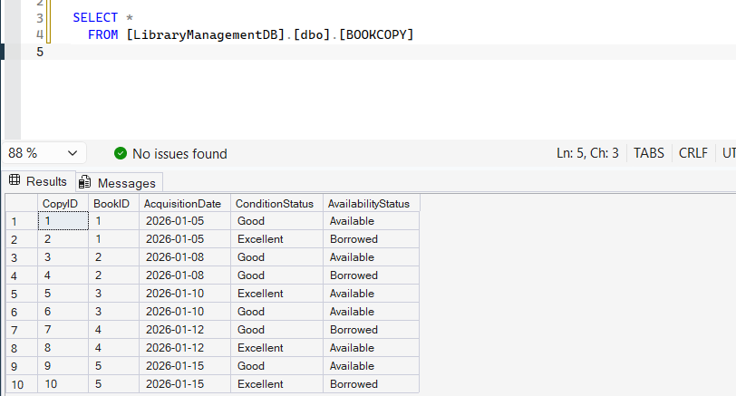
Figure 13 : Select from Bookcopy
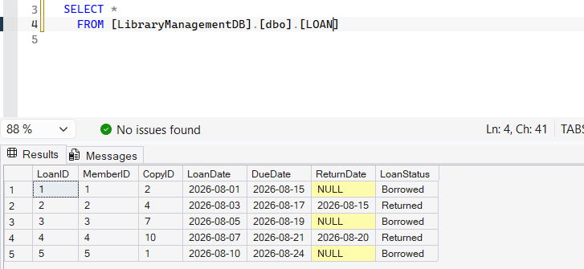
Figure 14 : Select from Loan

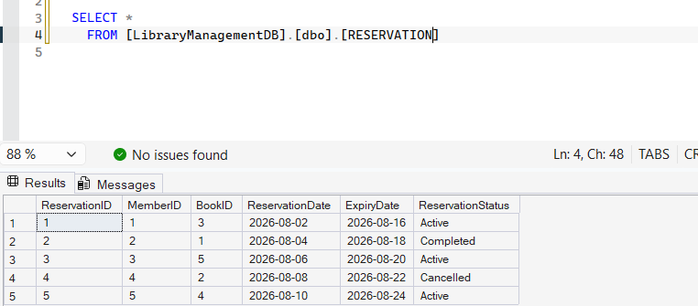
Figure 15 : Select from reservation
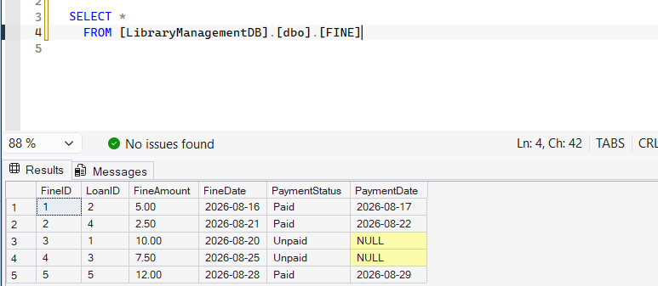
Figure 16 : Select from Fine
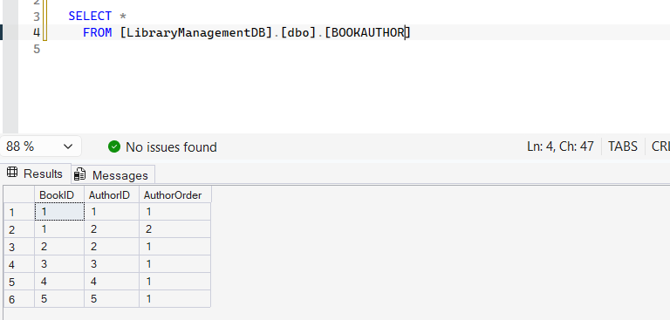
Figure 17 : Select from Bookauthor

6. Task 4 - Sample SQL Queries

Query 1: ORDER BY
This query retrieves the member data from the MEMBER table and sorts them alphabetically by their surnames. ORDER BY ASC is used to ensure that the names appear in ascending order.
USE LibraryManagementDB;
GO

SELECT
MemberID,
FirstName,
LastName,
Email,
MemberType,
Status
FROM MEMBER
ORDER BY LastName ASC;

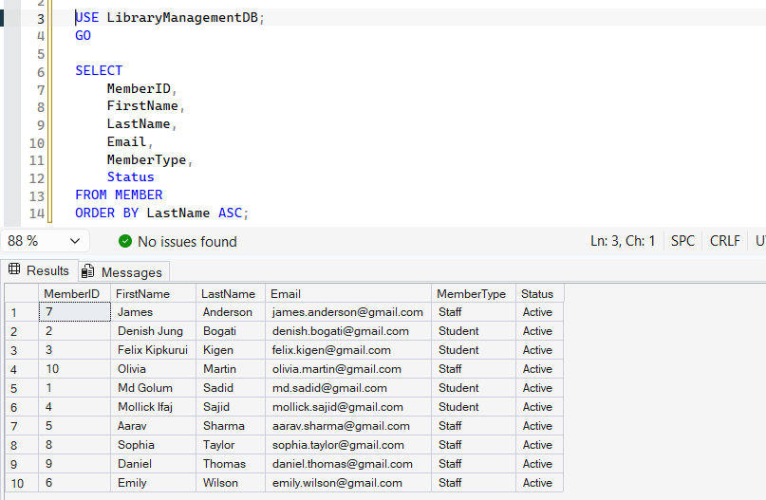
Figure 18 : ORDER BY Query

Query 2: LIKE
This query searches for books that have the word "Database" in their title. The LIKE keyword works together with the % symbol in order to allow any character before and after the searched word.
SELECT
BookID,
ISBN,
Title,
PublicationYear,
Edition,
Language
FROM BOOK
WHERE Title LIKE '%Database%';

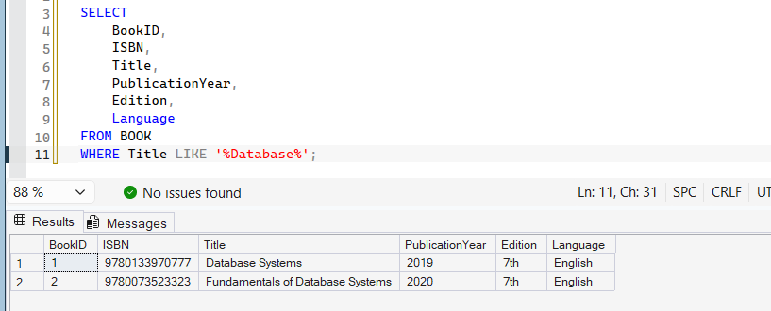
Figure 19 : Like QUERY

Query 3: Aggregate Function
The above query uses aggregate functions to get a summary of the books found in the database. The COUNT() function will return the total number of books, while AVG() returns the average publication year of the books.
SELECT
COUNT(*) AS TotalBooks,
AVG(PublicationYear) AS AveragePublicationYear
FROM BOOK;

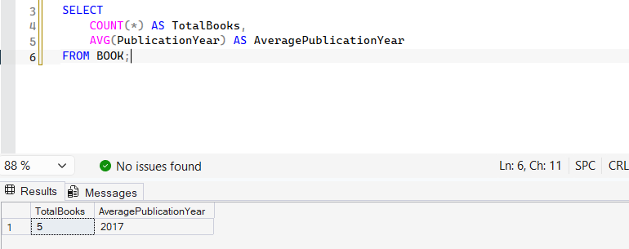
Figure 20 : Aggregate Function

Query 4: Aggregate Function
This search retrieves books that have been written from the year 2018 to 2021. The BETWEEN operator is used to specify this range, including the upper and lower boundaries. These results are then sorted based on the year.
SELECT
BookID,
Title,
PublicationYear,
Edition
FROM BOOK
WHERE PublicationYear BETWEEN 2018 AND 2021
ORDER BY PublicationYear;

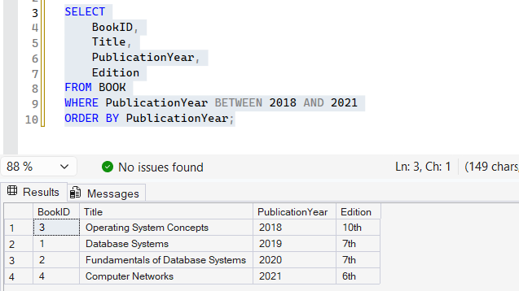
Figure 21 : Between Query

Query 5: JOIN
This query makes use of INNER JOIN to join the tables LOAN, MEMBER, BOOKCOPY, and BOOK. It identifies the member who borrowed which book and shows the loan details for the same. It is an example of how related tables can be joined using foreign keys.
SELECT
L.LoanID,
M.FirstName + ' ' + M.LastName AS MemberName,
B.Title AS BookTitle,
L.LoanDate,
L.DueDate,
L.ReturnDate,
L.LoanStatus
FROM LOAN L
INNER JOIN MEMBER M
ON L.MemberID = M.MemberID
INNER JOIN BOOKCOPY BC
ON L.CopyID = BC.CopyID
INNER JOIN BOOK B
ON BC.BookID = B.BookID
ORDER BY L.LoanDate;

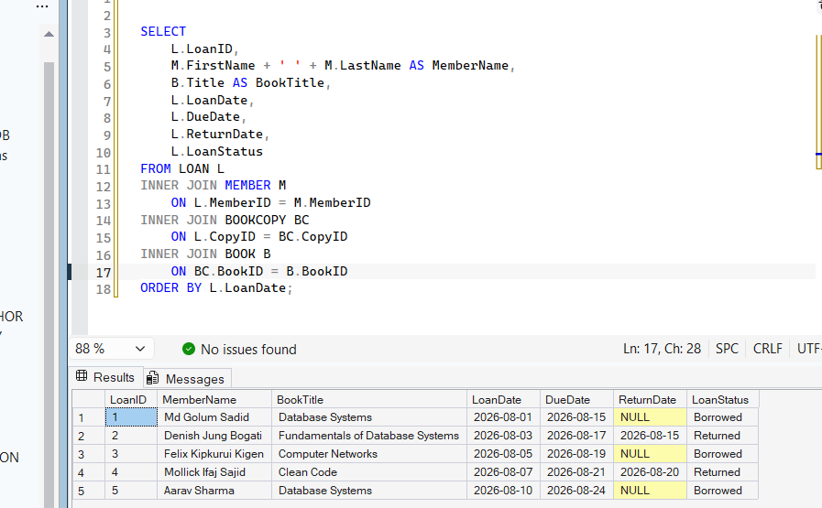
Figure 22 : JOIN Query

Query 6: UPDATE

UPDATE MEMBER
SET Status = 'Inactive'
WHERE MemberID = 5;

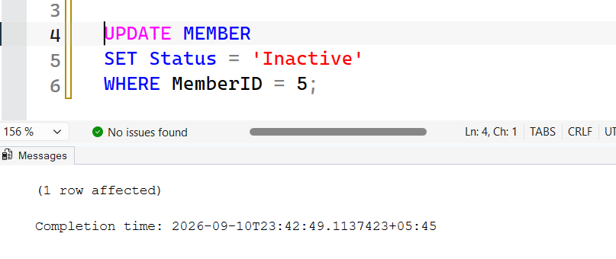
Figure 23 : UPDATE Query
SELECT
MemberID,
FirstName,
LastName,
MemberType,
Status
FROM MEMBER
WHERE MemberID = 5;

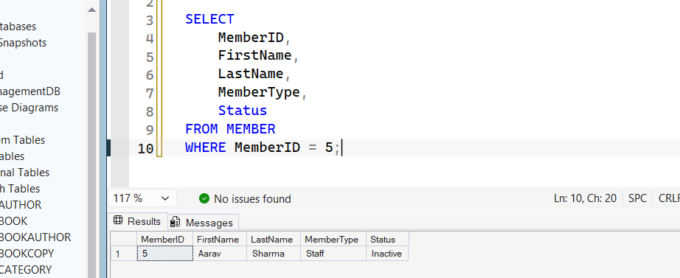
Figure 24 : Select query to check updated value

7. Task 5 - NoSQL Queries (MongoDB)

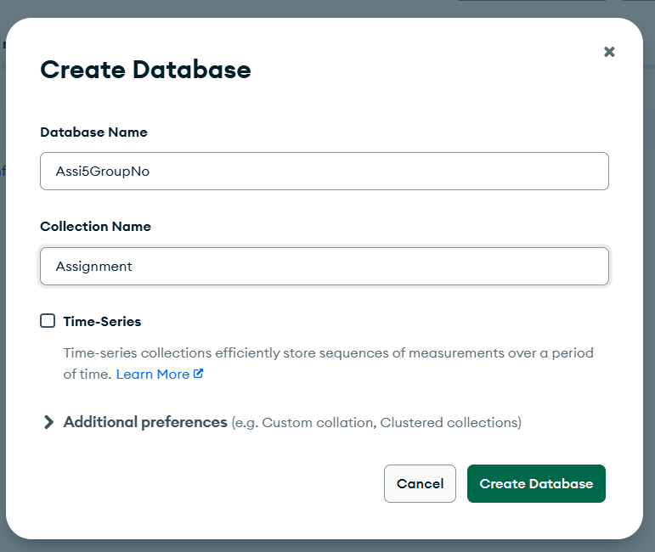
Figure 25 : Creating MongoDB Database and Collection
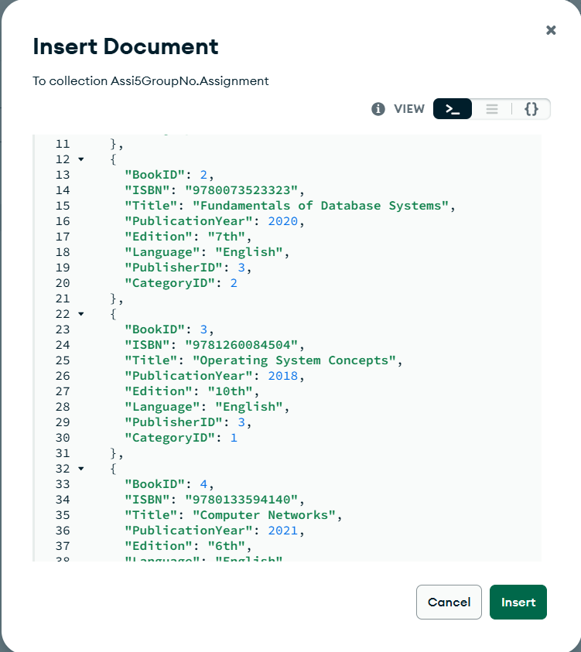
Figure 26 : Inserting Documents
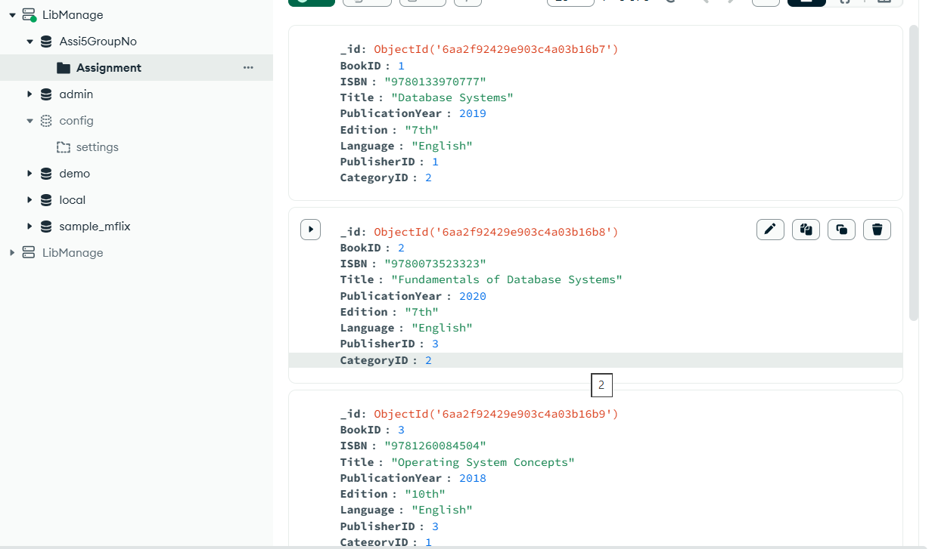
Figure 27 : Displaying All Documents
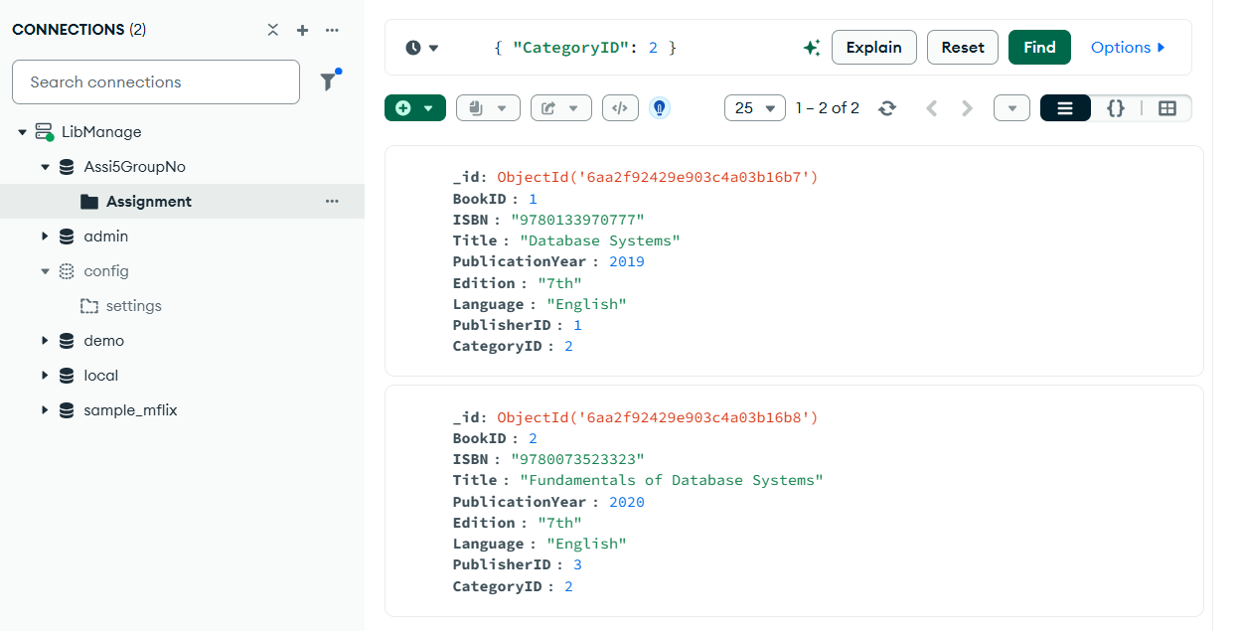
Figure 28 : Filtering Documents
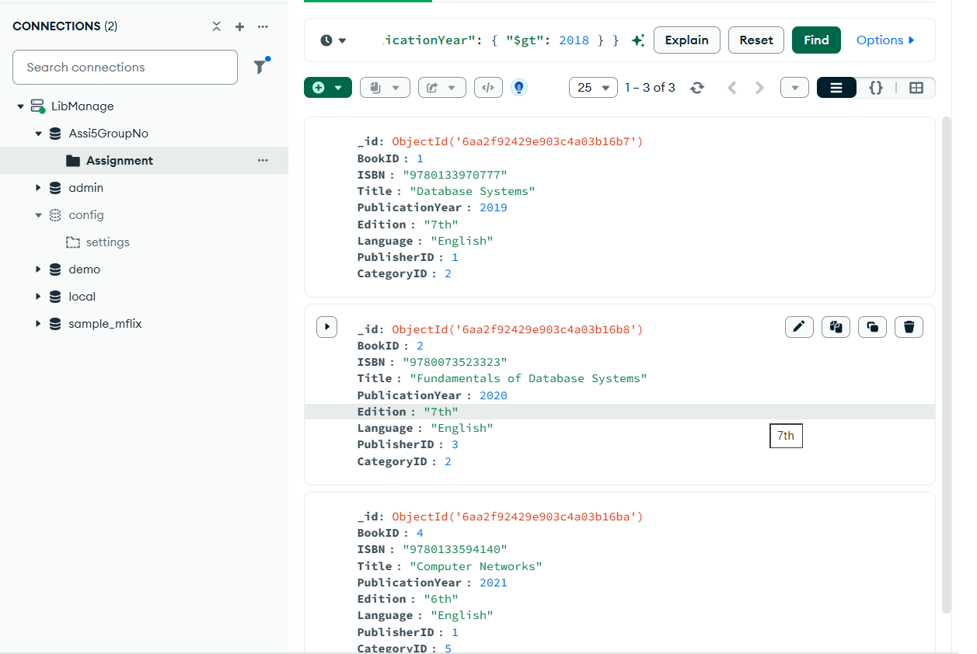
Figure 29 : Comparison Query
The NoSQL database has been successfully created for the Assi5GroupNo database in MongoDB. There were five books added to the Assignment collection. The filtering and comparison queries have been executed to show basic functionalities in MongoDB. This assignment shows the storage of Library Management System information in a document-based NoSQL database.

8. Task 6 - Concurrency Control and Transaction Processing
Effective transaction processing and concurrency control is important in maintaining integrity, security, and efficiency of the Library Management Database System when several people access the database at once. For example, when two members are trying to borrow the same physical copy of the book simultaneously, each transaction will initially identify the book as available, leading to the allocation of the same book copy to the two members. Concurrency control ensures that only one transaction is able to change the status of a book copy from Available to Borrowed at a time. Borrowing process can be defined as a transaction where book availability is checked, a loan transaction is created, a book copy is updated and then committed; when something goes wrong, the transaction can be rolled back to prevent incomplete data. Integrity can be assured using such techniques as primary key, foreign key, NOT NULL constraint, and UNIQUE constraint to maintain accuracy and consistency of data. Security can be achieved by means of access control and principle of least privilege allowing librarians, administrators and other people to access only necessary information and functions. Backing up the database regularly will allow protecting information about members, books, loans, reservations and fines from accidental deletion or failures. Normalization of the database, appropriate indexing, efficient SQL queries and transaction management can increase efficiency. Hence, transaction processing and concurrency control play a crucial role in the effective functioning of the Library Management Database System.

9. Conclusion
The Library Management Database System provides a practical demonstration of the use of basic principles in designing and developing databases. This study highlights the basic entities and their relationships using an Enhanced Entity-Relationship Diagram (EERD). Relational schemas for the database are created by normalizing the design up to Third Normal Form (3NF). Implementation of the database is done using Microsoft SQL Server, with the inclusion of proper primary keys, foreign keys, constraints, and sample records. The use of SQL is demonstrated through different types of data retrieval and manipulation operations, while the implementation of NoSQL using MongoDB is used to demonstrate a document-oriented database. The project covers topics including transaction processing, concurrency control, data integrity, security, backup and recovery, and efficiency of the system.

10. References
- Elmasri, R. and Navathe, S.B. (2016). Fundamentals of Database Systems. 7th ed. Pearson.
- Connolly, T. and Begg, C. (2015). Database Systems: A Practical Approach to Design, Implementation, and Management. 6th ed. Pearson.
- Silberschatz, A., Korth, H.F. and Sudarshan, S. (2019). Database System Concepts. 7th ed. McGraw-Hill Education.
- Microsoft (2026). SQL Server documentation. Microsoft Learn.
- MongoDB (2026). MongoDB Documentation. MongoDB.
- Project Management Institute (2017). A Guide to the Project Management Body of Knowledge (PMBOK Guide). 6th ed. Project Management Institute.
- ICT200 Database Design and Development. Assessment 3: Database Design and Development. Course assessment document.

11. Appendices

Appendix A - EERD
Enhanced Entity-Relationship Diagram of the Library Management System
The EER Diagram specifies the entities, attributes, primary key, foreign key, relationship, cardinality, participation constraint, and specialization of MEMBER into STUDENT and STAFF.

Appendix B - SQL Server Database Implementation
LibraryManagementDB in SQL Server Management Studio
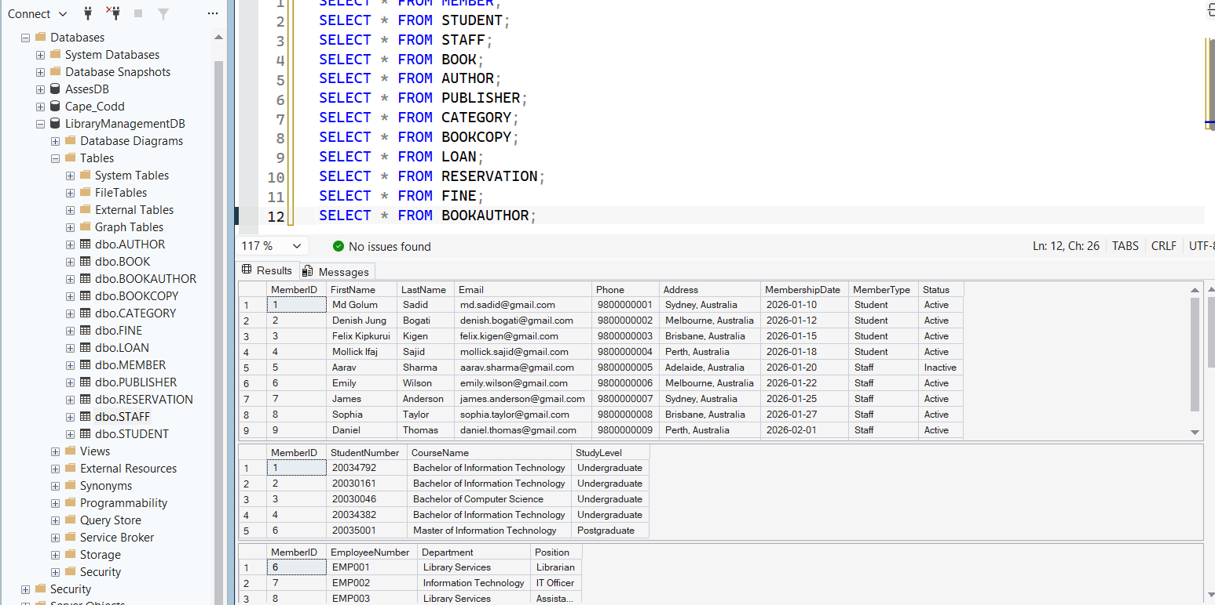
The database contains the following relations:
- MEMBER
- STUDENT
- STAFF
- BOOK
- AUTHOR
- PUBLISHER
- CATEGORY
- BOOKCOPY
- LOAN
- RESERVATION
- FINE
- BOOKAUTHOR

